# Template Yii2: How does it work?

# Important

## First time

When you configure config\db.php and insert the db\all.sql file into mysql database and run the app from apache or another server. You should see the login page. Use username/ password (admin / 23011994).

Dashboard will not work you need to change it depending on your needs. But r=user (<http://localhost/web/index.php?r=user>), r=all/gender(<http://localhost/web/index.php?r=all%2Fgender%2Findex>) will work

## Mentronic template how I made it.

At the compressed file which I sent you in the theme/classic there are 12 themes which all use the same basic files (run the index in every folder to see them) , the only diff its in the theme/assets/css/demo8/style.bundle.min.css and /theme/assets/js/demo8/scripts.bundle.js which are also in the app\asset\AppAsset.php file. You could change them but you need to see the examples

## Gii

Είναι διαθέσιμο στην διαδρομή r=gii

ή

<http://localhost/web/index.php?r=gii>

### Export models

You should always export models at app\models\generated and override them at app\models\pure

Cause when you make changes to the db you don’t need to change everything. You just generate the specific model and replace it via GII

### 1.2) Export Crud

You should always use overridden model as Model dld app\pure\User

You should use as search model path the app\search\(model_name)Search dld (app\search\UserSearch

And for the controllers use app\controllers\(controller_name)Controller dld app\controllers\UserController

Also enable I18N (translations) and Pjax (its ajax for yii2 and reloads data at index page for the controller without refreshing the page)

# Structure

## 2.1 assets folder

Has only one file inside which includes all the template theme and my files that I need all the time in the app.

The commented files, are files that app doesn’t use but where in the template

### 2.2 controllers folder

All the controllers must have at their name the word controller (required by yii)

You should always override the CController.php file to the controllers that does not need an logged in user and AuthedController.php to logged in user.

At AuthedController.php there are many configuration that you can do, but also has the only_admin and only_manager which means when its enabled by the child (extended) only that type of user can access it. And yii has many functions in the controllers one of them its beforeAction which is called before every action on controller, so when you need to prevent access, you just return false.

Also, for every action in controller the name must have at start the word “action” example. If you need to create a function that shows dashboards of an individual user as an admin. An example would be the function actionDashboardUser($user_id) at controller UseController.php and can be accessed by url

r=user/dashboard-user&user_id=1

### 2.3 folder db

Contains the basic sql commands. Run the when you create the database

### 2.4 helpers folder

This folder is created by me in order to have a clean code without making controllers large in size and unreadable.

I usually create files inside there depending on the functionality and group them by the folder example app\helpers\notification\... has all the files for creating a notification for user

Also has the DashboardHelper.php file which I use for the dashboard in order to show graphs and numbers and the output from the view should look like something like this (screenshot its from another app which I used this template)

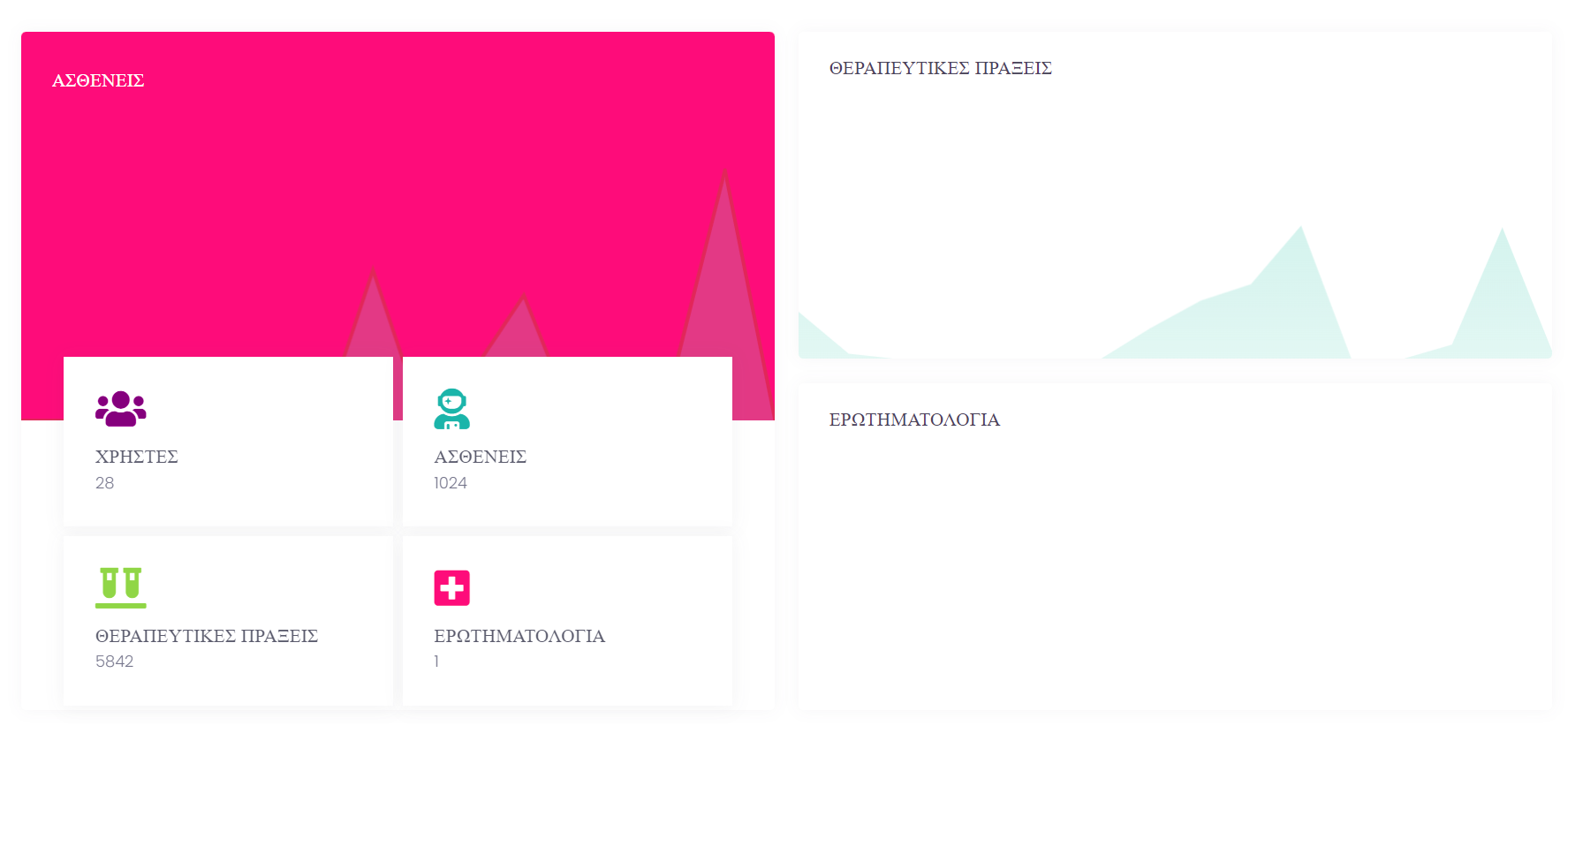

Σου εχω αφησει επίτηδες τα προαγόμενα helpers για παράδειγμα.

### 2.5 messages folder

Contains child folders depending on the locale you wish to import.

Example messages\el\app.php contains all the translated words for the Greek language and you should change the $greek array cause the default its for the yii messages

### 2.6 models folder

All the models inside should have a parent the Model.php (παραδειγμα ακομα και στο generated folder όλα τα αρχεια κανουν extend to model και με την σειρα του γινεται extend στο pure folder έμμεσα, στην συνεχεια το ιδιο γινεται και στο search folder)

**Folder generated**

You should generate files from gii inside this folder and just change the extends parent

**Folder pure**

You should extend every file in generated folder in order to make the changes that you need and always use this file model instead of generated.

**Folder search**

This is used by the controller index page(generated from crud)

### 2.7 views folder

For every controller that you want to show data you must have a folder of the controller’s name, required by yii (example UserController.php should have a folder at views with name user, BuddyPooperController.php should have a folder buddy-pooper)

**Layouts folder**

This has all the templates for every user type. And its selected by CController.php at setLayout which means “admin” value sets the file layout\admin.php

Check topBarAll.php which shows the menu for every type of user, I use the objects in the folder app\helpers\menu, check the objects and you shall understand.

### 2.8 web folder

Index.php it’s the file that runs the whole app.

**Folder assets**

This folder its autogenerated by yii (don’t delete it, it will autogenerate when you do)

**Folder upload**

I upload inside this file all the files that are uploaded in the website.

#### 2.8.1 theme folder

**Web\theme\assets** are all the files that I have copied from the metronic theme, I have not altered them I just use them.

Web\theme\custom are all the custom files that I have created in order to show a pretty and functional website. I have left all the examples inside